Ex.1: Explain how the distribution changes with respect to the change in covariance matrix.

1. Identity matrix yields a circular Gaussian distribution in 2 dimensions, or a hypersphere in higher dimensions, where each component has a variance of 1.

sigma = [1 0;0 1]

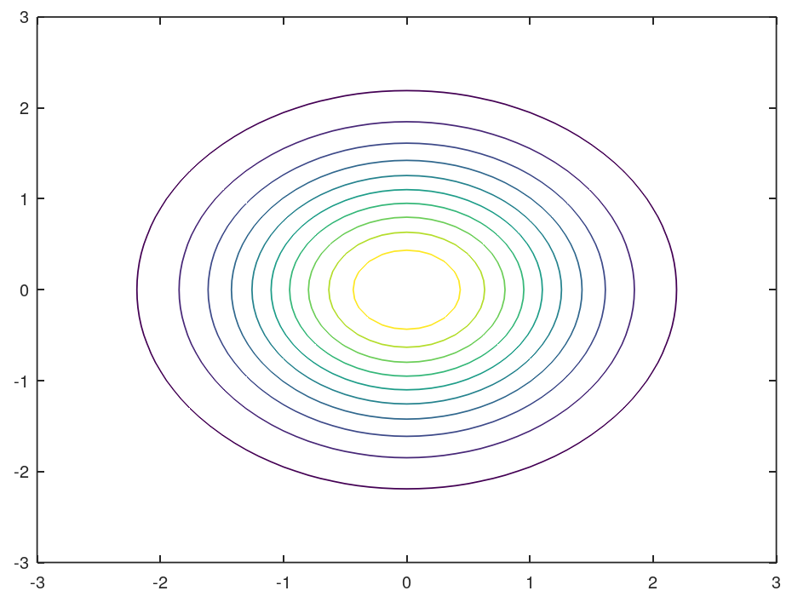

1. If we scale the individual components, this will cause the distribution to be ellipsoid, but still oriented along the axes.

sigma = [2 0;0 2]

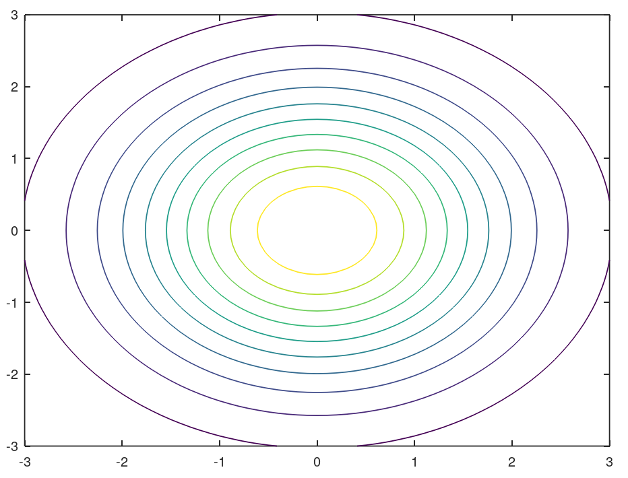

1. If the sub-diagonal values are the same positive values, the distribution constructs along y = x. The closer the values are to 1, the greater the degree of contraction.

If the sub-diagonal values are the same negative values, the distribution constructs along

y = -x+b. The closer the values are to -1, the greater the degree of contraction.

sigma=[1 0.5; 0.5 1]

sigma=[1 -0.9; -0.9 1]

Ex.2: Estimating parameters of 1D Gaussian distribution

1. function[]=gauss1d_MLE(n,mu,sigma)
2. X = sigma*randn(n,1)+mu;
3. mu_MLE=mean_MLE(X);sigma_MLE=var_MLE(X);
4. X = -3:0.5:3;
5. Y = g1_pdf(X,mu,sigma);
6. disp(['true:',num2str(Y)]);
7. Y_MLE=g1_pdf(X,mu_MLE,sigma_MLE);
8. disp(['estimated:',num2str(Y_MLE)]);
9. plot(X,Y,'ro-',X,Y_MLE,'gx-');
10. legend('true','extimated');
11. endfunction
12. function[z]=g1_pdf(x,mu,sigma)
13. z=(2*pi*sigma.^2)^(-1/2)*exp(-(x-mu).^2./(2*sigma.^2));
14. endfunction
15. function [my_mean]=mean_MLE(X)
16. N=size(X,1)
17. my_mean=(1./N).*sum(X)
18. endfunction
19. function [my_var]=var_MLE(X)
20. N=size(X,1)
21. my_mean=(1./N).*sum(X);
22. my_var=0;
23. for k=1:N
24. my_var=my_var+(X(k)-my_mean).^2;
25. end
26. my_var = (1./N).*my_var
27. endfunction

**Outputs1：**

>> gauss1d_MLE(10,0,1)

N = 10

**my_mean** = 0.3052

**my_var** = 0.7298

**true:** 0.0044318 0.017528 0.053991 0.12952 0.24197 0.35207 0.39894 0.35207 0.24197 0.12952 0.053991 0.017528 0.0044318

**estimated:** 1.9237e-05 0.00033857 0.0037268 0.025656 0.11046 0.29742 0.50086 0.5275 0.34745 0.14313 0.036874 0.0059414 0.0005987

**Outputs2：**

>> gauss1d_MLE(20,0,1)

N = 20

**my_mean** = 0.1372

**my_var** = 1.0293

**true:** 0.0044318 0.017528 0.053991 0.12952 0.24197 0.35207 0.39894 0.35207 0.24197 0.12952 0.053991 0.017528 0.0044318

**estimated:** 0.0037247 0.01455 0.044892 0.10939 0.21053 0.32 0.38416 0.36425 0.27277 0.16133 0.075358 0.027802 0.008101

With the increasing of the number of data points，MLE of mean is closer to 0；MLE of variance is closer to 1.

Ex.3: MLE of multi-dimensional Gaussian distribution

E.4: Estimating parameters of 2D Gaussian distribution



